1. Download the SQL SERVER 2019 edition from the Microsoft Site

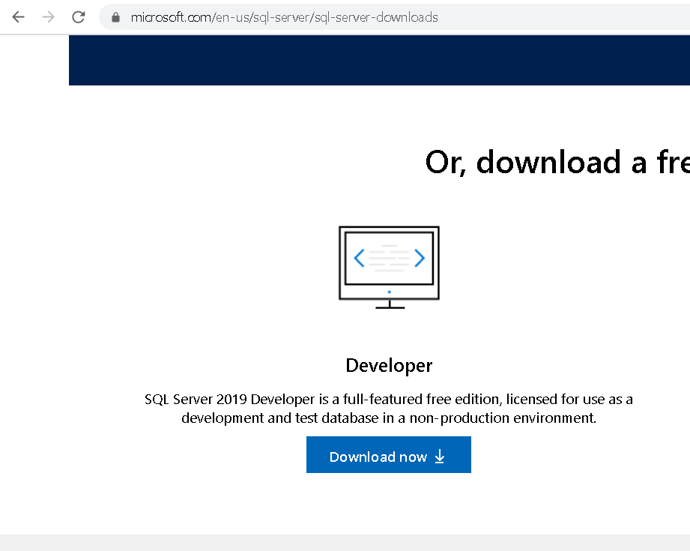

1. You will see in your download location something like below:



1. Double click on the install icon and Select the custom option. You can also download the media file first. I usually prefer the media option so that I can install it later as well:
2. Downloading will start and will take some time based on the internet connection speed:

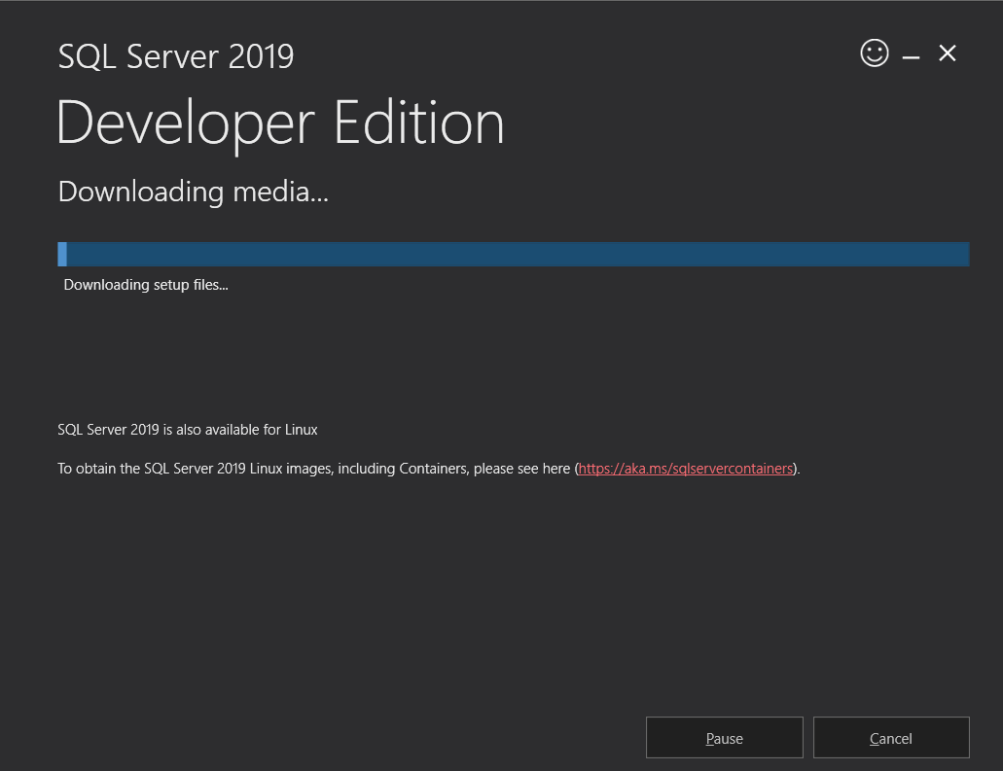

1. Once download is complete you will see a .exe file and .box file as below:



1. Simply click on the .exe file and it will open up the installation center:

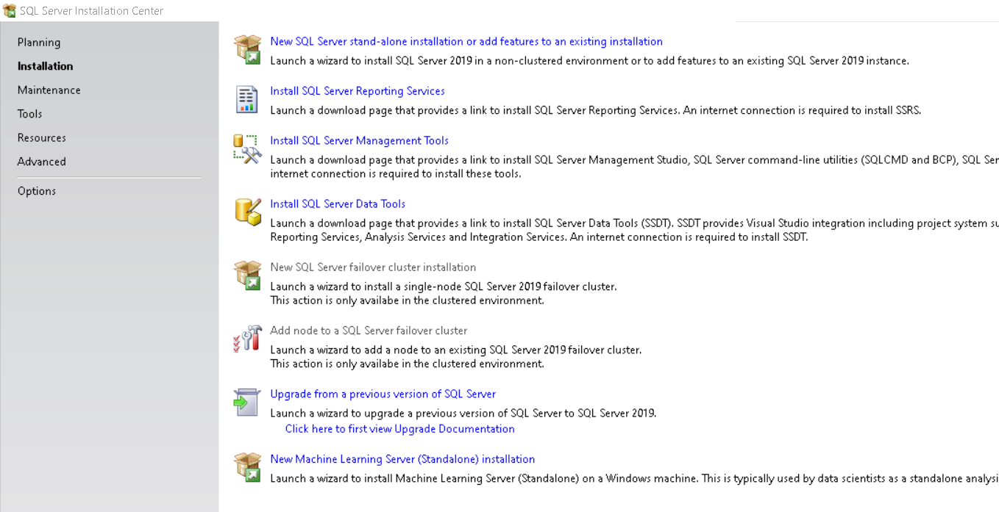

1. Multiple things can be installed from here. Kindly select first option for the fresh installation:
2. Let’s install the default options available as of now, we can add or remove the things later on as well:

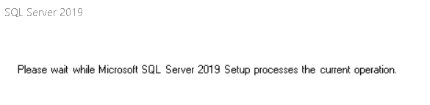

1. Click on Next:

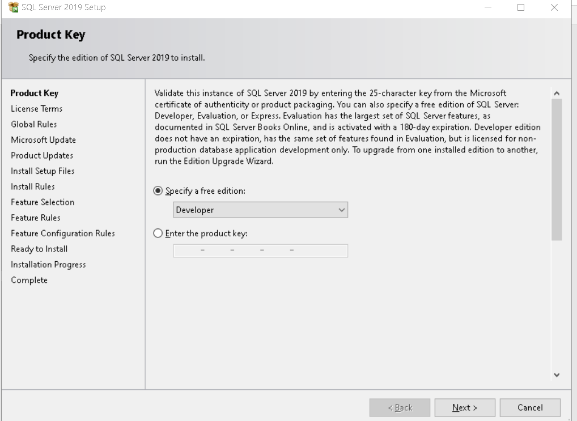

1. Simply click on next and next and below step will take some time:

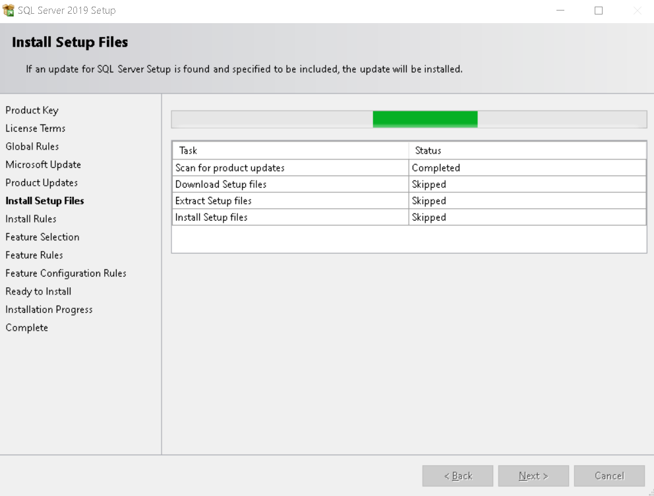

1. Select below options to install the SQL Server. We are selecting specific features only:

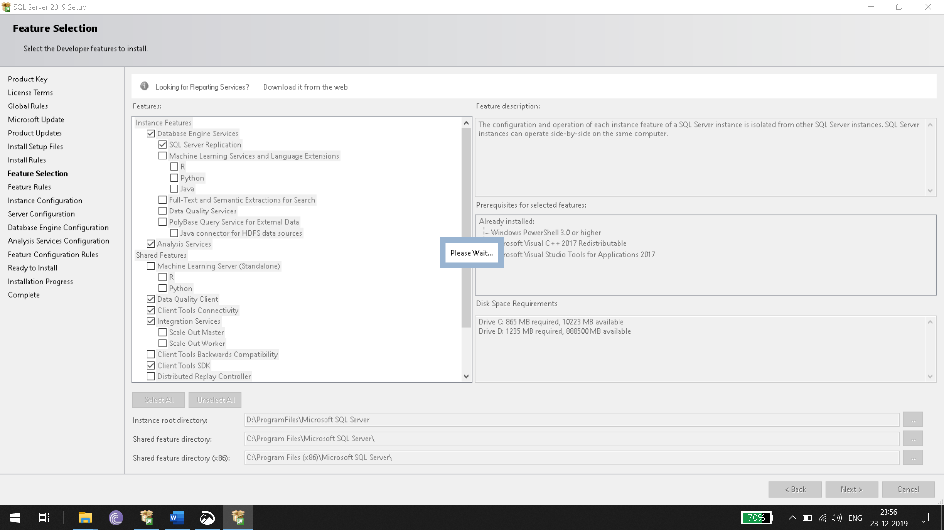

1. Select Default instance

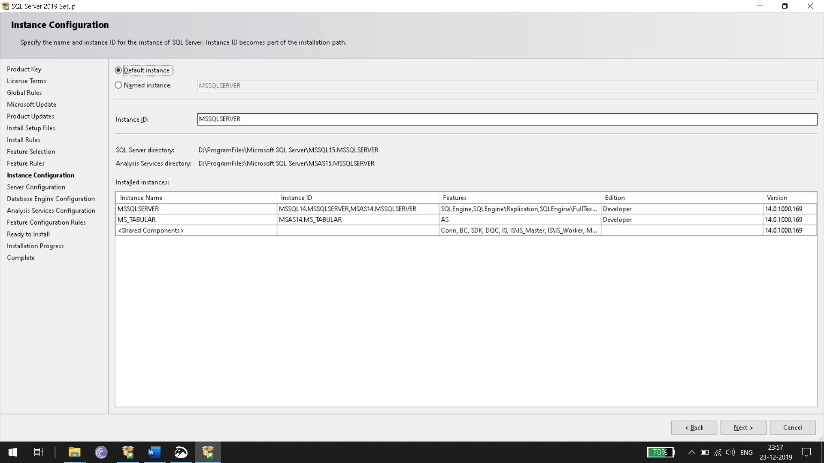

1. Set below as well in default state
2. 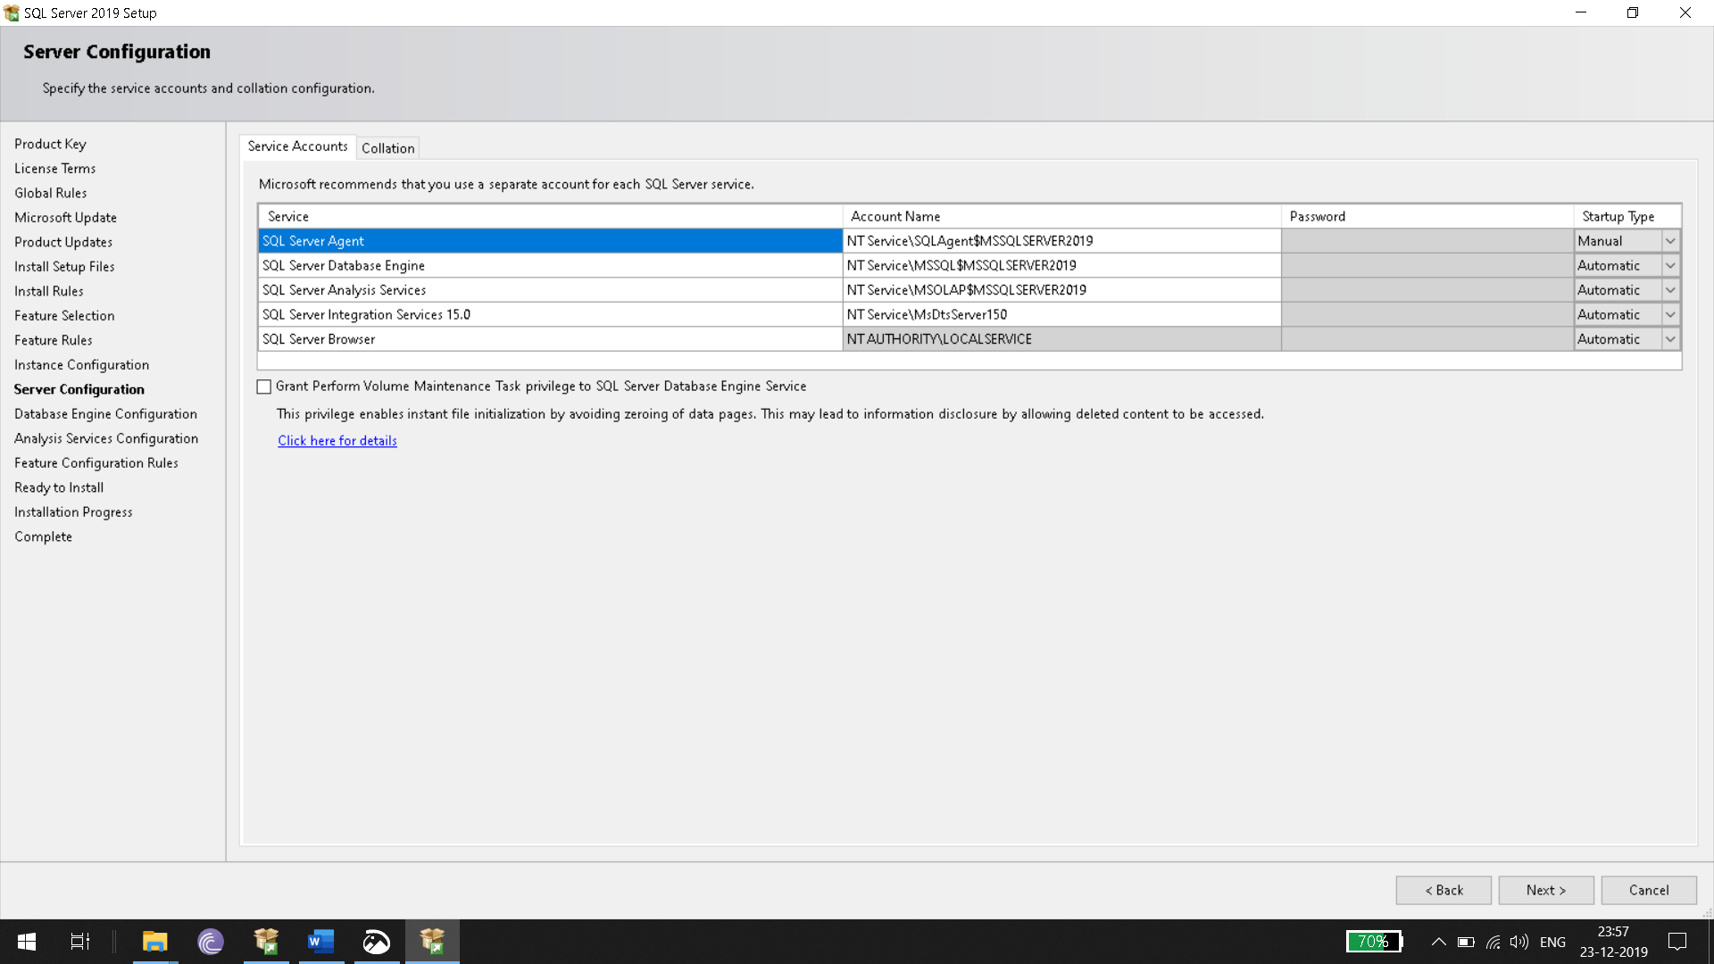
3. Click on add current user for below window:
4. 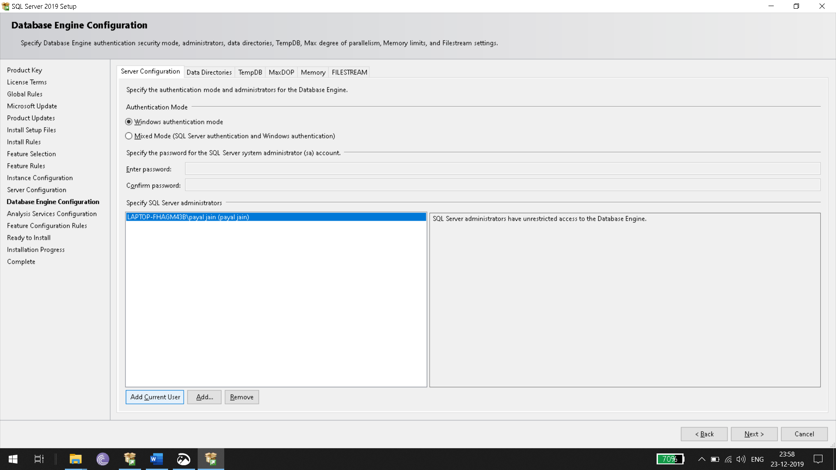
5. Same Steps related to Add Current User should be followed for the Analysis Services as well.
6. You can also follow below Video. Please don’t follow video blindly, just make sure that you have developer edition with you. Select the custom option and just see the video for reference. It may be possible that few things are not relevant for you. So ignore them.
   1. <https://www.youtube.com/watch?v=1H1nBxmRSok>